Template for Extended Abstracts for ISCRAES 2022

**Theme:**

Title

Khalil, M.I.*1, D.A. Fornara2 and B.A. Osborne 3

*1, 2,3 Department, Institute, COUNTRY.* (*corresponding author: Email)

**Abstract**

100 words

***Keywords:*** Up to 5 words.

**Introduction**

150 words.

Any citation included must be numbered and the full should be included under the reference.

**Results and Discussion**

Text, 1 Table and 1 Figure (or 2 Tables/Figures), Caption: TNR Font 10.

Any citation included must be numbered and the full should be included under the reference.

Text……………………………

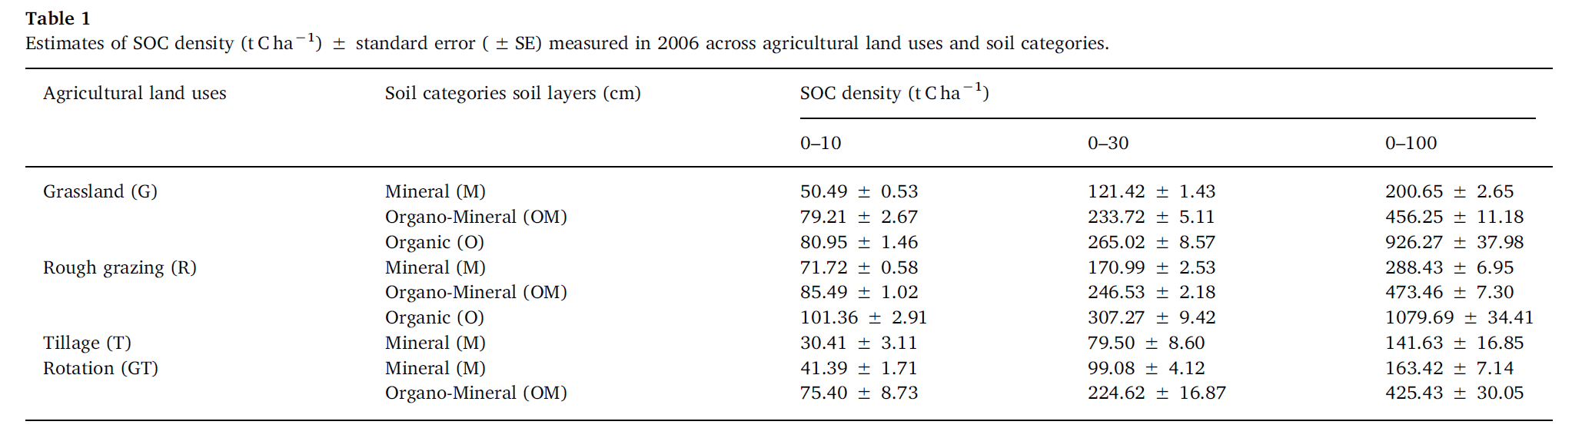

Text………………………..



**Fig 1.** Estimates (corrected) of annual SOC density changes (25 years average) in three soil layers (0–10, 0–30 and 0–100 cm) and categories (mineral=M; organo-mineral=OM and organic=O) under major agricultural land uses (G=Grassland, R=Rough grazing, T=Tillage and their rotation GT) and its overall annual sink. Vertical bars indicate standard errors (±SE).

**Conclusions**

Max. 100 words.

**Acknowledgement**

Max. 30 words.

**References**

ANR Font 10

Max. 10 references.

1. Khalil, M.I. and B. Osborne. 2018. Improving estimates of soil organic carbon (SOC) stocks and their long-term temporal changes in agricultural soils in Ireland. Geoderma 322, 172-183.